**Cuizine:**

Chicken Karahi

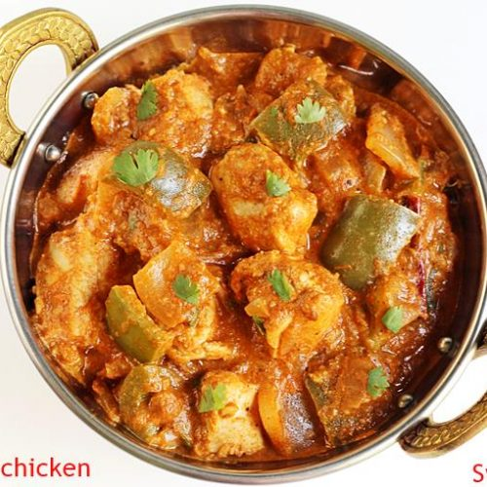

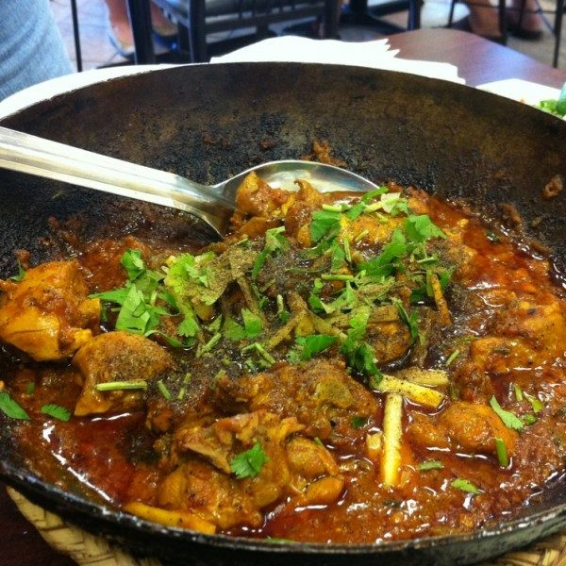

**Chicken karahi**, also known as **gosht karahi** (when prepared with goat or lamb meat instead of chicken), and **kadai chicken**, is a dish from the Indian subcontinent noted for its spicy taste; it is notable in Pakistani and North Indian cuisine. The Pakistani version does not have capsicum or onions whereas the North Indian version uses capsicum. The dish is prepared in a karahi (wok). It can take between 30 and 50 minutes to prepare and cook the dish and can be stored for later consumption. It can be served with naan, roti or rice. This dish is one of the hallmarks of Indian and Pakistani cuisine.